Public Geographic Information Platform Based on LightSwitch and Baidu Maps API – Taking Hongshan District Information Publishing Platform as an Example
Li, xiaofei, He, jin &Jiachaowei, Wen,boge
Resources and Environment Institute, Hubei University, Wuhan, Hubei, China
ABSTRACT: With the development of GIS technology and the advancement of information construction, it requires higher demand for geographic information sharing. This paper presents a way to build the geographic information publishing platform by using LightSwitch framework and Baidu Maps API , which you can quickly publish spatial data collection, support efficient data management, geographic data presentation and data analysis function. Simple to maintenance and easy to implement, the system greatly improve the efficiency of information platform development. This article also discusses the implementation of Stadium Information Platform in Hongshan District.

Introduction
Along with the continuous advancement of information construction in our country, as well as the development and popularization of GIS Technology, the information construction of various institutions has also raised to a new height. From the past single attribute data warehousing management to the present forms of data display, geographic information service technology is becoming more and more mature. Application of geo-graphic information system management application has been very common for national, provincial and municipal administration. From a technical standpoint, the current mainstream map services such as Baidu Maps and Autonavi Maps have provided fully functional online map services, they all have a high degree of market acceptance to meet the public demand for online geo-graphic information querying and browsing; In market perspective, many administration departments are in urgent need of sharing digital presentation through the map for geographical data, instead the traditional textual form.
In this paper, we present a way to construct the geographic information publishing platform by using Microsoft newest developing framework and Baidu Maps API, through the use of LightSwitch data service interface and a wealth of geographic representation of Baidu map, to realize the rapid construction of geo-graphic information platform, So as to meet the needs for data collection, management and geographic information release.

Demand analysis
With the advent of information age and the popularization of electronic government affairs, Units at all levels have more and more urgent demand for the publication of electronic information. Therefore, we need to find a solution to the rapid construction of information storage, information management, information dissemination and query. And with the popularization of the geographic information service, the demand for the publication and display of the geographic information is also more intense. To comprehensive analysis of the above requirements, the system should achieve the following functions:
- Data management. To realize the user information data management, such as data acquisition, input, edit, query etc.
- Map data display. Some of the basic functions of the map display, such as feature points cluster display, Panoramic Map roaming, real-time traffic information display, etc.
- Statistical analysis of data. To achieve the base spatial analysis of the map points data such as heat maps, and to analyses attribute data by pivot table and chart, etc.
- Authority management. To realize the system user rights management in different levels.
- Rapid construction, maintenance is simple.

System design

System framework design
Our system uses current popular four tier structure including interface tier, business tier, data interface tier and data tier.
- The UI tier: Based on Internet/Intranet, through the browser and client software to display query result, user information and processed result provided by business components, such as data query UI, the statistics and analysis charts UI and electronic map UI, etc.
- Business logic tier: Including function modules of various business components and responsible for the function of collaboration and data exchange between modules to achieve complete business processes. It is the core part of the system.
- Data interface tier: Encapsulating the function of database accessing to decouple the business layer and the data layer.
- Data tier: It used to store data in a MS-SQL Server databases such the Coordinates data and user configuration informations, etc.
The system framework is shown in Figure 1:

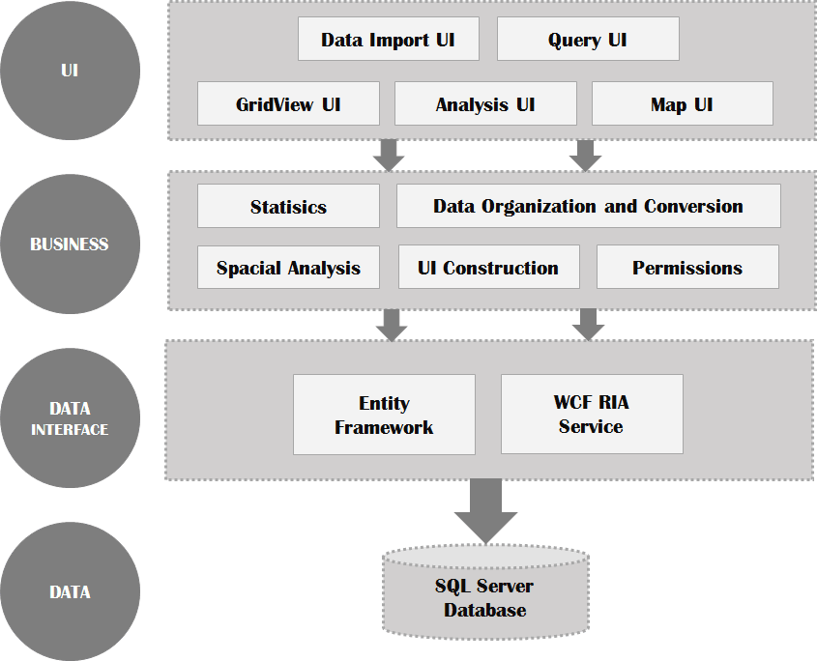

Figure 1: The diagram of system architecture

Database design
The system use SQL Server as the database management software. Stadium information related to spatial data and attribute data. According to the characteristics of Stadium data and their relationship, we have designed stadium base information table, stadium table, stadium category table, streets table, stadium economy status table, stadium photo table, stadium owner table, etc. The specific relational database see Figure 2. Spatial position information is represented by latitude and longitude. The spatial information associated with the stadiums in order to process the spatial orientation and corresponding query.

System implementation

Technology Platform Introduction

LightSwitch
Visual Studio LightSwitch is a development environ-ment designed to simplify and shorten the development of businesses applications and data services. LightSwitch makes it easy to create data-centric business applications that can consume a variety of data sources and create cli-ents that can run on a variety of devices. It can shorten the development time greatly. At the same time, thanks to the good data packaging of LightSwitch, The maintainability of the program is significantly improved.

Baidu Maps API
Baidu Maps JavaScript API is a set of application inter-face written by JavaScript that can help us build rich, interactive online map applications, Baidu maps also provide powerful map data and panoramic data support which can provide a better data browsing experience for users. In addition Baidu map API’s rich interface, perfect development documentation can greatly reducing the development difficulty.

jQuery EasyUI
The front end framework for web UI, it is a set of plug-ins based on jQuery and helps us build feature-rich and beautiful user interface web applications.

HighCharts
Powerful, open, beautiful, rich chart, good compatibility, pure js charting library. Combined with pivottable control can generate variety of analytical charts dynamically.

System implementation methods
The implementation method is a new attempt by combining Microsoft LightSwitch with Baidu map. By using LightSwitch data package characteristics and Baidu Maps API strong support on the map data to realize the rapid construction of the online publishing platform of geographic information data.
Specific development flow can be divided into the following main stages:
- Use LightSwitch platform to build the overall framework. First creating LightSwitch solution, then creating “DesktopClient” and “HTMLClient” projects separately, which “DesktopClient” is a data edit and management project, while “HTMLClient” is a map data display client project.
- In "HTMLClient" project, we write custom UI pages to replace the LightSwitch default "HTMLClient" project web pages. However we could still retain the data interface which LightSwitch provides for us to query data at the same time.
- Use the front-end UI framework "jQuery EasyUI" to build the HTML page, at the same time calling Baidu Maps API to generate the online map.
- Use the open source control "pivot table" combine with the chart control "HighCharts” to generate the statistical and analytical charts dynamically.
- User rights system, generating different HTML pages depending on the user’s permissions to ensure the data security.

Key technologies of system implementation

Customize the web user interface
By adding the “HTMLClient” project into the solution, LightSwitch will create the “Screen” folder automatically. After finish adding HTML screens as the case requires, the system will automatically generate the form de-signer interface according to the data provided by the data table. At this point, the default data view mode is "Row Layout", replace the default layout control "Row" with "Custom Control", then the system can be dis-played according to user-defined HTML interface. In the system, LightSwitch provides two interfaces: “element” and “content Item”, the “element” is used to accept the custom HTML interface, we only need to design a HTML document and attach it to the “element” argument to implement a custom web page; the contentItem is the data interface of LightSwitch which provides a screen property to query and load data function. In order to achieve access to the data in the database.

Baidu Maps asynchronous loading
The map module is core modules of platform, the map loads correctly and displays in the appropriate view of the page is very important. However, during the entire page's initialization, due to differences in the users’ network performance, the Maps API loading speed is also different, using the traditional way of map loading will be a disaster for the poor network users which may cause the page block and the browsing experience will reduce greatly. Here by using Baidu Maps API asynchronous loading technology, add the callback parameter when calling Baidu Maps API, the callback function will be executed immediately after Baidu Maps have been loaded so that other function modules will not be blocked. Moreover, when the user fails to load the map, it does not affect other modules work properly.

Use RIA technology to enhance the efficiency of the system inquiry
With the continuous growth of data in the system, query efficiency of the system will decrease continuously. In this case the system query efficiency can be improved by using WCF RIA （Windows Communication Foundation Rich Internet Application） Services.
WCF RIA Services simplifies the development of n-tier solutions for Rich Internet Applications (RIA), through the use of RIA services, we can create intermediate da-ta tables on the server side and re-organize the data what we really need to post (for example integrate multiple data tables, connect, and consolidate data tables to provide services such as count, sum and other functions). Moreover, once we create a RIA Services client, the client will automatically update with latest middle tier logic every time that the solution is re-compiled [6]. The following illustration (figure-2) shows a simplified version of n-tier application. RIA Services focuses on the box between the presentation tier and the data access layer (DAL) to facilitate n-tier development with a RIA Services client. Tests show that the use of RIA Services can greatly improve the query efficiency of LightSwitch applications.
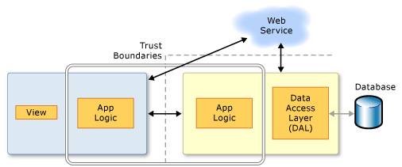
Figure 2: the n-tier application and RIA Services effective region
In the Hongshan stadium geographic information publishing system, by using RIA services to re-organize data at server, we built “stadium” table and “economy status” table to provide the web-side browsing data. After we have adopted the RIA services, the time queried for 2000 records reduced to 3s, however it used to take 40s at beginning.

Permissions system implementation
For information platform, data security is the most important feature. We use the authority to ensure the user‘s data security. The system can identify different log-in users by verifying the permissions. Once a user has been authenticated, the system will set the special UI and functions for him according to his permissions. Although LightSwitch has provided a complete permissions-based authorization system, as shown in figure-3 [9], since we re-write its default HTMLClient UI, so we could not take full advantage of its permission system. Fortunately, we can custom LightSwitch original permission system to control the user access to HTML pages and functions.
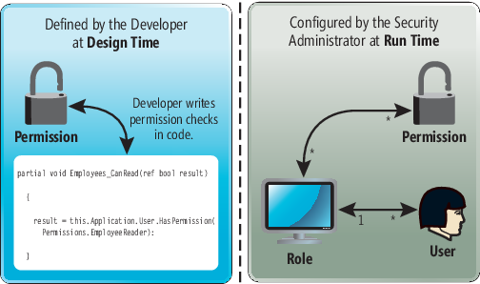
Figure 3: Implementing Authorization in LightSwitch
First, obtain the current user’s permissions in the web client. After getting the user permissions on the server side through the LightSwitch “ServerApplicationContext” API, we can request it from the web client. Secondly, construct the HTML pages dynamically. Create HTML elements by JavaScript code and insert them into the HTML document separately. During the construction of each HTML element, the authority management module will check whether the current user has the permission to build the special element, by this way we can achieve the goal of restrict the user’s unauthorized behavior.

Heat Map Analysis
A heat map is a graphical representation of data where the individual values contained in a matrix are represented as colors [new2]. Here we use it as a statistic map layer to cover the Baidu Maps to describe the stadiums space and attribute statistic information. With the help of Baidu Maps API open source library we can easily build the stadium geographical heat map of at-tribute statistics.
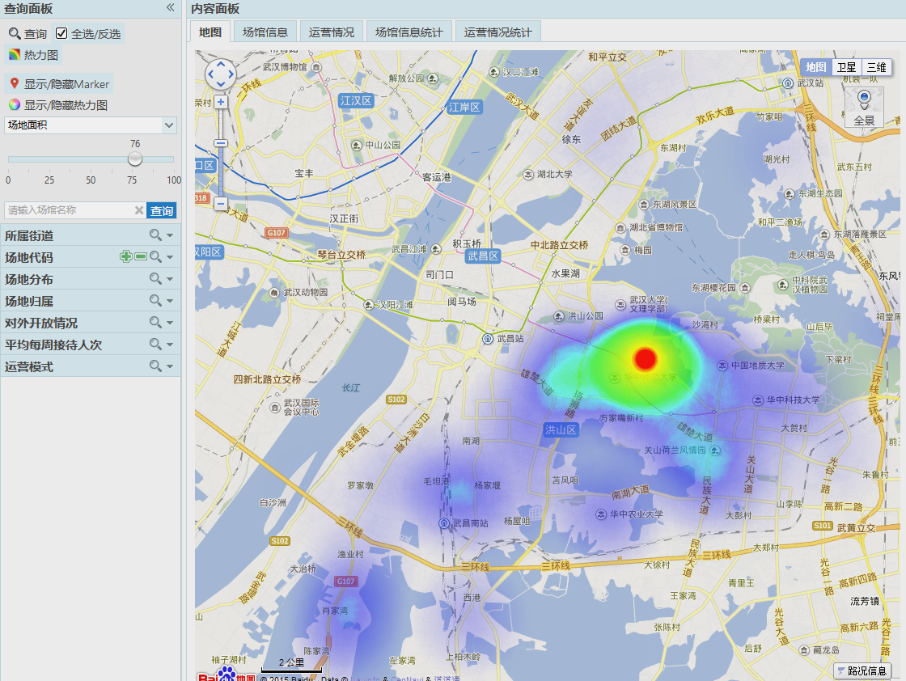
Figure 4: the heat map result of stadiums area statistics

The system UI
According to the system design, the specific development flow and the key technologies, we have implemented the Hongshan district stadium information publishing platform based on LightSwitch and Baidu Maps API successfully. The system operation interface is shown blow.
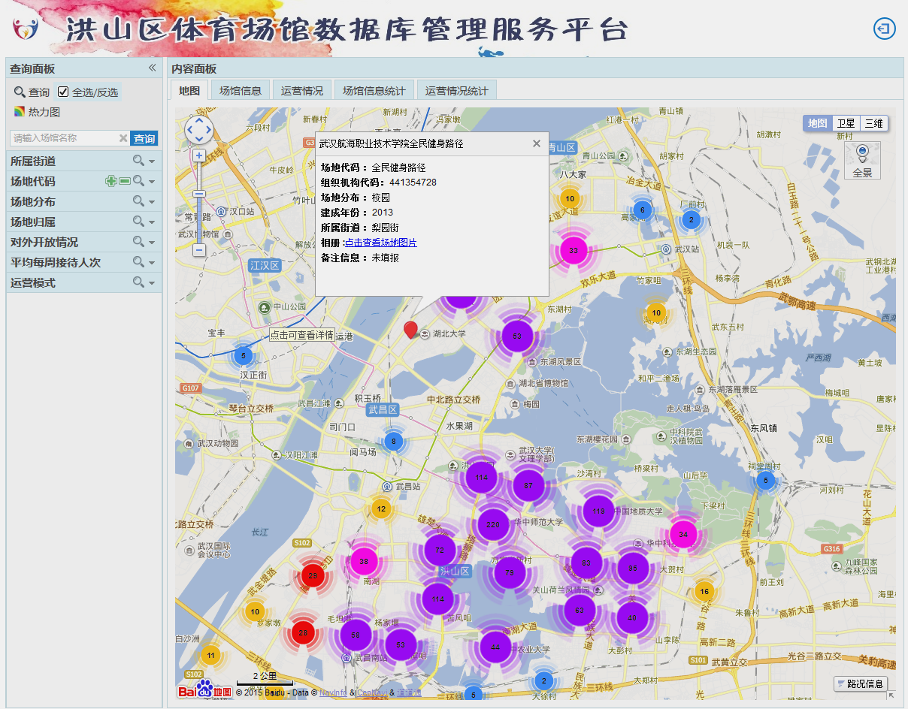
Figure 5: the query result of stadiums

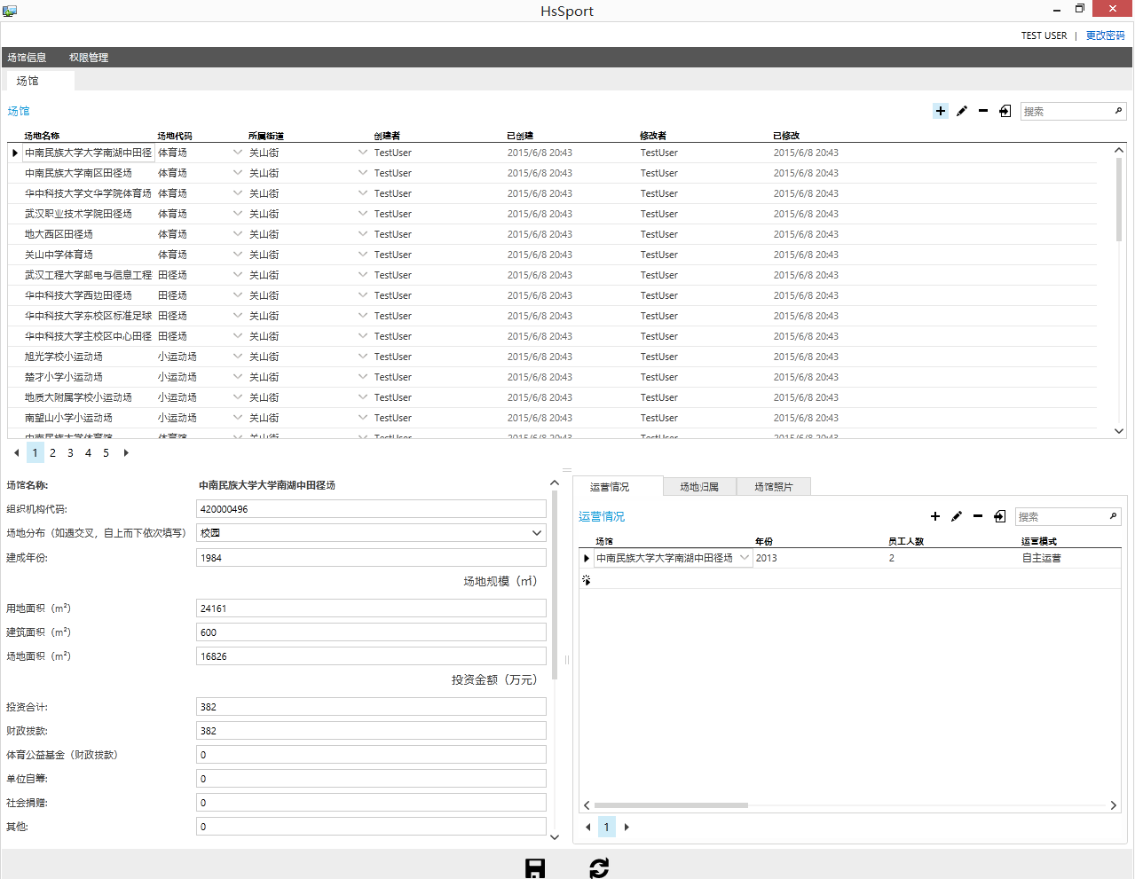
Figure 6: The database management interface

summary
By the way of combining the LightSwitch development framework with Baidu map API, we can effectively solve the traditional platform construction drawbacks such as long-term building, complex processing, high cost of construction and maintenance, etc.
In this paper, we take Hongshan district stadium information publishing platform as an example to intro-duce the key technologies of an agilely solution to build the geographic information publishing platform by Microsoft LightSwitch and Baidu Maps API. During the test of platform operation, it proved that the solution is easy to use and simple to maintain. Though the use of RIA technology, the query efficiency has improved significantly and can achieve the performance requirements.
References
Massi, B. (2011) Visual Studio LightSwitch - Advanced Programming Made Easy with Visual Studio Lightswitch [Online] Available from: https://msdn.microsoft.com/en-us/magazine/hh335061.aspx [VOLUME 26 NUMBER 08].
Leung, T. (2012) Creating and Using RIA Services. Visual Studio LightSwitch 2012. 2nd edition. Boca Raton, FL, CRC Press. pp. 2–81.
Book: chapter in an edited book

Washington, M. (2013) Using ServerApplicationContext. Creating HTML5 Websites and Cloud Business Apps Using LightSwitch in Visual Studio 2013. 2nd edition. Boca Raton, FL, CRC Press. pp. 2–81.
Andersen, V. ,Evans, M. ,Shah, S. &Simons, M. (2011) LightSwitch Security - Securing Access to LightSwitch Applications [Online] Available from: https://msdn.microsoft.com/en-us/magazine/hh456409.aspx [Volume 26 Number 10].

